
10 Steps to Overall Your Health & Body
Steps to Help Professional Women Over 50 Become Healthier & Happier while Rocking Their Transformed New Bodies

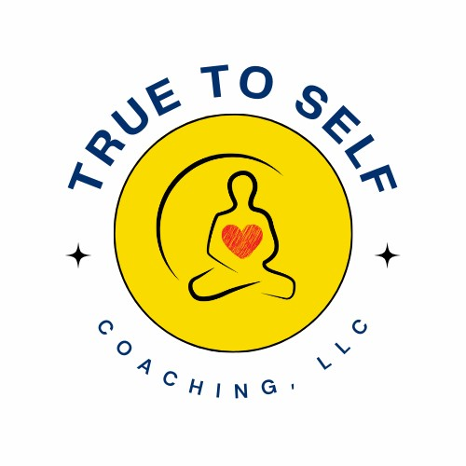
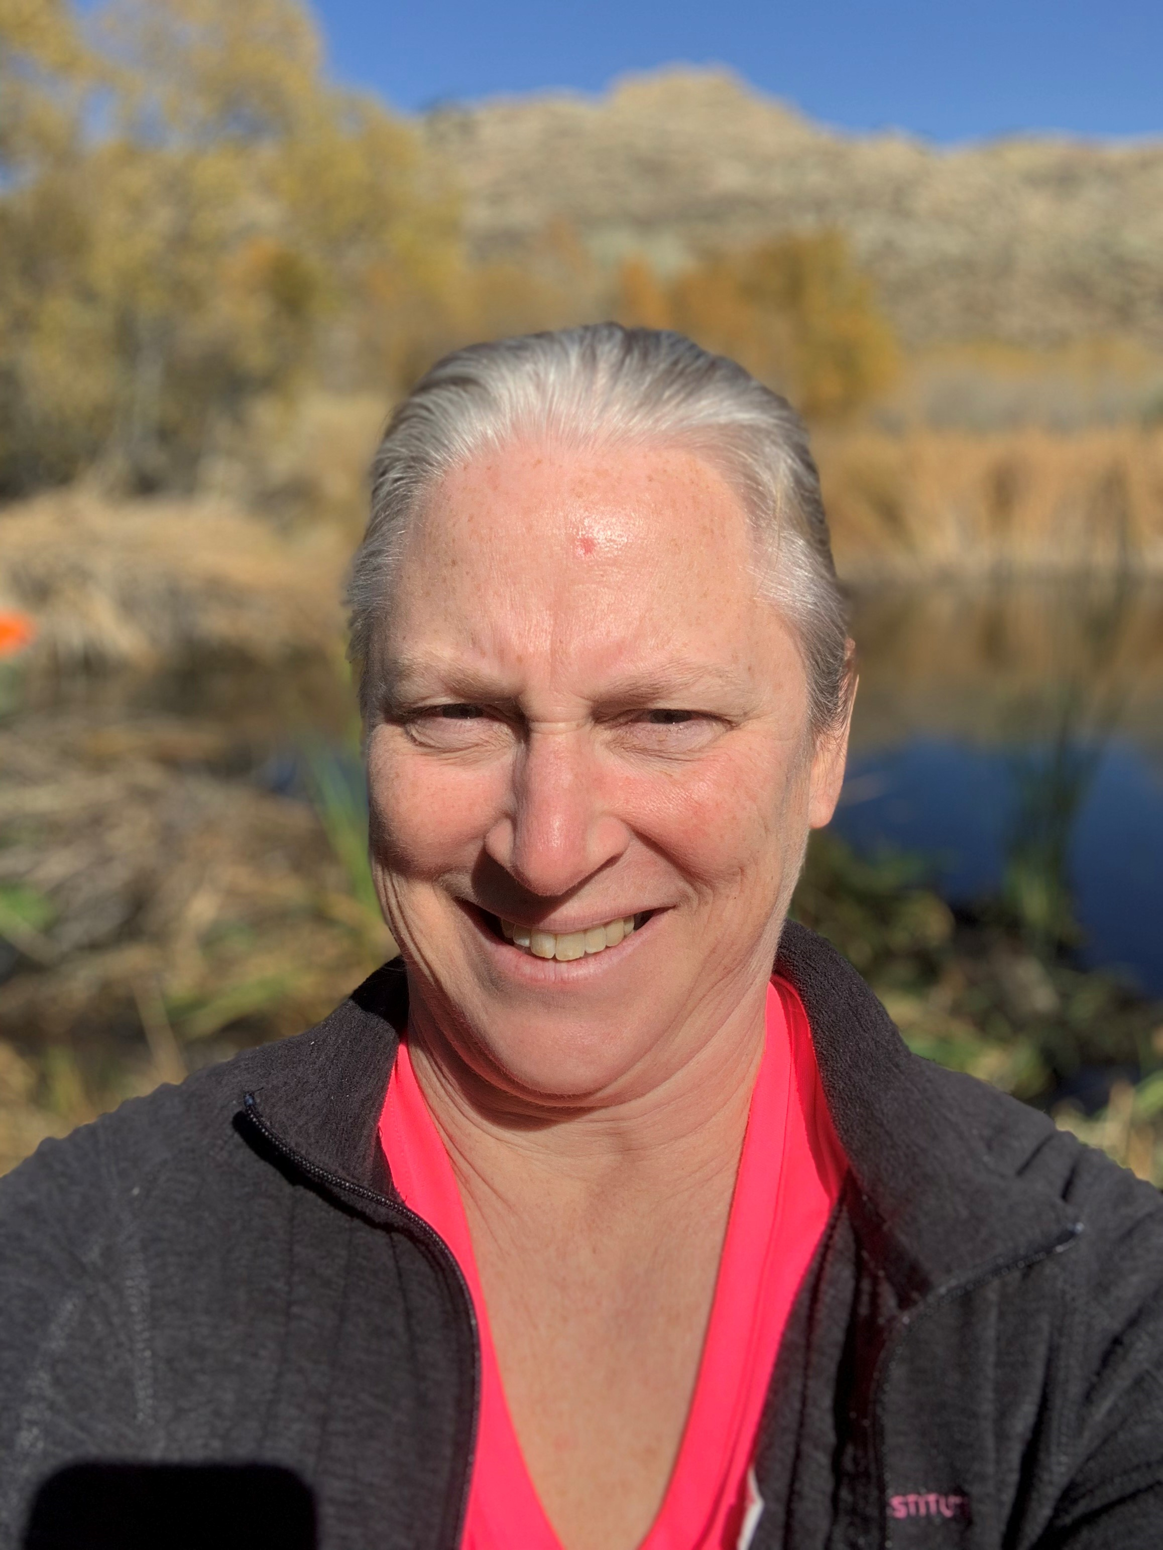

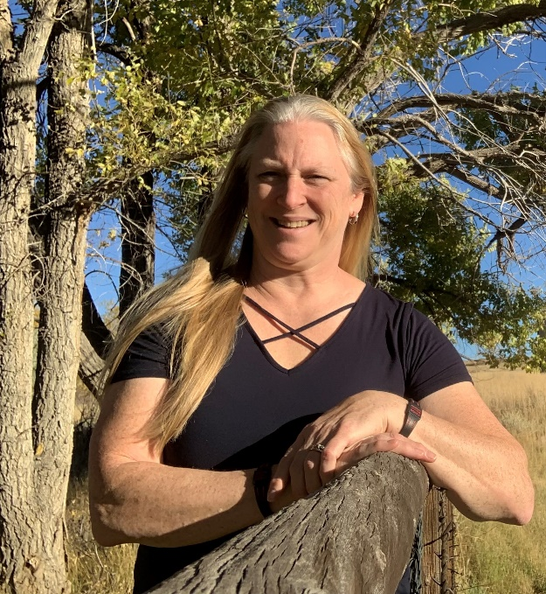
Bonnie Neff, RN
Certified Mastery Health & Life Coach and Certified Clarity Catalyst Trainer

I’m Bonnie Neff, a seasoned nurse with a passion for guiding individuals towards their best health. With a rich 29-year nursing journey from the bedside to leadership and executive roles, I’ve transitioned into a dedicated Health & Life coach, driven by a mission to empower lasting well-being.
Embrace a Holistic Path: Today, as a Health & Life Coach, I blend my nursing expertise with the art of coaching to provide comprehensive support. Together, we’ll explore your physical health and beyond, addressing mind, body, and spirit.
bonnie@truetoselfcoaching.com truetoselfcoaching.com (573)-247-6063

Feeling as if your years of caring for everyone else’s needs has placed your own health and body on the back burner? Have you suffered from a lack of life balance, energy, time for self-care and always eating the wrong foods on the run been your method of operation for years? Now, it’s time to reclaim your health and body back or have the body you’ve always dreamed of.
10 Steps for Women Over 50
Overhaul Your Health & Body

By taking these holistic steps, you can create a practical approach to your well-being that addresses your physical, mental, emotional, and spiritual health. Practicing these steps will help you foster a healthy, balanced and fulfilling life while rocking the body you desire.

Comprehensive Health Assessment: You will need to start with a comprehensive health assessment of your physical health. If you haven’t had a check-up in the past year or medications and/or have health issue history, make an appointment with your practitioner to discuss your overall health, your plan to exercise and desire to get healthy. Your assessment should include all aspects of your being, including regular check-ups, preventative exams, mental, emotional, and spiritual well-being. After this is completed, you are ready for your overhaul journey to begin.

- Set Realistic Goals: Establish clear, achievable goals. Focus on both short term & long-term goals. Make sure that your goals are realistic and motivate you, giving you a sense of accomplishment.
  - short term goals improving your flexibility or decreasing your sugar intake etc....
  - Long term goals weight loss, increased stamina, eliminating sugar etc...

- Mindful Eating & Portion Control: Practice mindful eating by focusing on savoring each bit and recognizing when you start to get full (80%) and stop. Be mindful of what types of foods you are eating and portion sizes. Try to avoid emotional eating and avoid high carb and sugary snacks. Try preparing small amounts of healthy foods in baggies so you have them on hand. Only eat when you are truly hungry. Eat one big meal a day and other 5 small healthy mini meals every 2-3 hours when awake.
  - Hydration: Hydration (water) is critical for maintaining your digestion, healthy skin, and overall bodily functions. Drinking an adequate amount of water is roughly a minimum of 64 oz. throughout the day. Drinking a glass of water before meals and when you’re not sure if you are really hungry decreases food cravings and helps you from overeating. Limit your intake of caffeine to 1 cup a day. Avoid drinks that have sugar or sweeteners.
  - Meal Length: Each regular meal should take you at least 15-20 minutes or longer to eat. This aids in digestion, decreases overeating and boosts your metabolism.
- Nutritious and Balanced Diet: Focus on natural whole fresh foods whenever possible, these are nutrient dense foods. Ensure you are getting a balanced intake of proteins, healthy fats, vitamins, and minerals during your day. Much better to get your nutrients from your food rather than vitamins whenever possible. Consider consulting with a coach or nutritionist if you need personal guidance. Consider doing mindful exercises before and during eating, such as using your senses while you eat, placing your fork down on the table between bites and chew each bite 20-30 times.

- Prioritize Positive Sleep Habits: Ensure you are getting enough quality sleep each night. For those over 50, the recommendation is 7-9 hours of quality sleep to support overall health. Taking a warm bath, sleeping in a cool room, using your bed only for sleep & sex, putting away electronics at least 2 hours before bedtime and avoiding caffeine after 3pm are all great ways to help you sleep better.

- Mindfulness & Stress Management: Integrate mindfulness practices such as meditation, journaling, or deep breathing exercise into your daily routine. Manage stress through mindfulness practices, relaxation techniques, doing something you love, hobbies and spending time in nature. There are many relaxation apps for your phone or find a yoga studio near you.

- Regular Physical Activity: Engage in physical activity that combines cardiovascular, strength, flexibility throughout your week. Choose your routine and physical activities that enhance your body and also your spiritual and mental well-being. Try something new, maybe it’s a movement that you loved when you were a kid. Have a 15-minute dance party with your grandkids or try hula hooping with them. Think outside the box and get that heart rate up.
  - Beginning: If you are just starting to exercise or you haven’t done it in a long time, make sure you check with your provider & they approve of your exercise routine for your safety. Start out slow at first and work your way up to the amount of time or days of the week.
  - Routine: Make movement part of your daily routine. If you already exercise daily, try new ideas and activities to boost your metabolism.

- Holistic Self-Care Practices: For years you may have let your body decline to care for others. Now, it’s your turn to take care of yourself. Prioritize at least 15-30 minutes a day to self-care activities you love that nurture your body, mind, and spirit. Maybe this is a massage, facial, aromatherapy, relaxing by the water or your favorite quiet spot, going for a walk alone in nature, journaling or other spiritual practices that contribute to your unique emotional and spiritual well-being.

- Positive Social Connections: Connect with like-minded community that understands and supports your values and your life journey. Sharing insights and experiences with others can be profoundly healing. Engage in social networks and activities that are positive and contribute to your overall well-being. Avoid people and groups that drag you down or are negative.

- Continuous Learning & Growth: No matter how old we are or what we have done in the past, it is never too late to learn and grow. Keep your mind active by pursuing hobbies, learning new skills and/or exploring new interests. Intellectual stimulation contributes to mental and emotional well-being.

- Gratitude and Positivity: Practice gratitude daily. Focus on positive aspects of your life, expressing gratitude for the present moment. Positive thinking enhances mental resilience and overall happiness. Ideas for this practice is writing down (journaling) the top three things you are grateful for each day, telling at least one person how grateful you are for them each day and looking at every situation and with best intensions turn those experiences into gratefulness, looking at the good in the situation.

We can partner together to develop strategies that will help you gain more energy, practice daily self-care techniques, regain balance and clarity so that you can step into better health and unlock that beautiful body you desire, for a lifetime. Reach out to me via e-mail, or phone to set up a FREE, “Thriving at 50 Plus: Your Health Reimagined Call~

